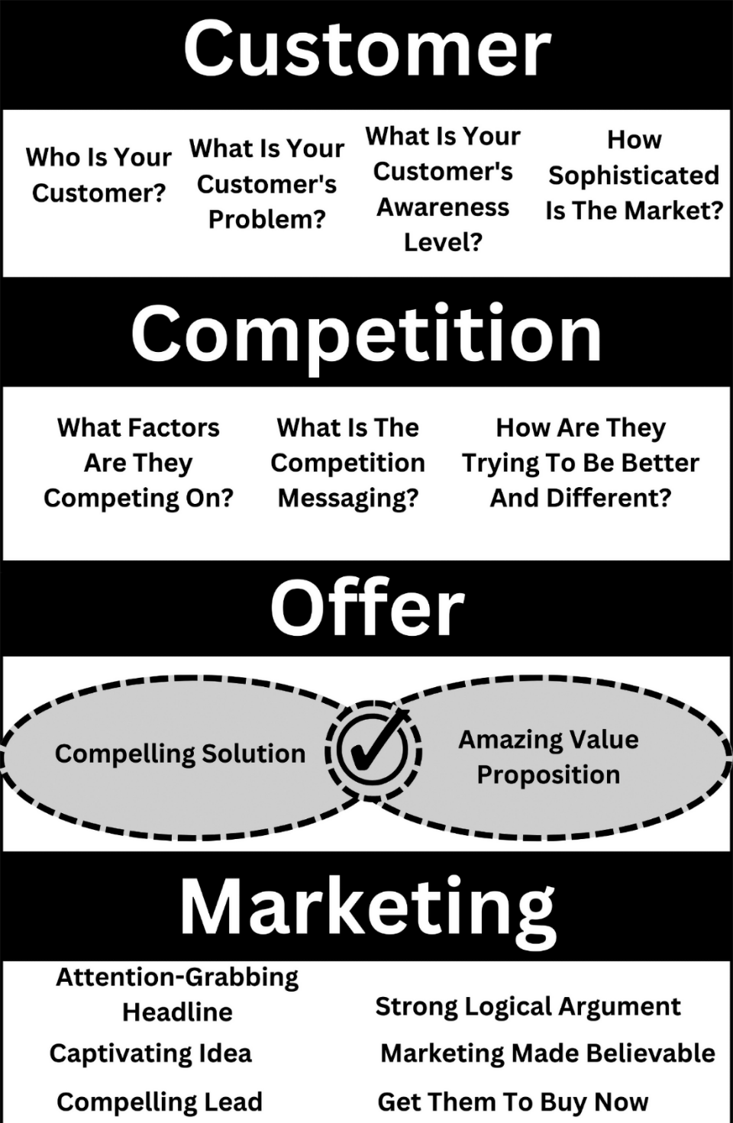
Copywriting Research Canvas One Page Summary

Get FREE tools & resources, upgrade to the advanced course, and get personal help from Kent at website www.CopyByKent.com

